|  |
| --- |
| HND |
| **Formulation and Implementation of College Management System Project** |
| **Unit 4: Project Design Implementation and Evaluation** |



Info Myanmar College

**Myint Myat Kaung**

Batch – 3

2nd year, second semester

Assignment (1)

**Start Date : 29.8.2017**

**End Date : 19.9.2017**



[1. Researching of Educational business in Myanmar 5](#_Toc498087309)

[1.1 Literature review for Educational organizations 6](#_Toc498087310)

[1.1.1 Info Myanmar College 7](#_Toc498087311)

[HR and Admin department functions 8](#_Toc498087312)

[Finance and Account department functions 8](#_Toc498087313)

[Student service department functions 9](#_Toc498087314)

[Teaching departments functions 9](#_Toc498087315)

[1.2 Description of IMC processes 11](#_Toc498087316)

[1.2.1 Enquiry and admission processes 11](#_Toc498087317)

[1.2.2 Attendance process 12](#_Toc498087318)

[1.2.3 Reporting process 13](#_Toc498087319)

[1.2.4 Library process 14](#_Toc498087320)

[Library Hours 14](#_Toc498087321)

[Rules for borrowing book 14](#_Toc498087322)

[1.3 Formulating and Recording two possible outline projects specification 15](#_Toc498087323)

[1.3.1 Project Scope 15](#_Toc498087324)

[Educational services process 15](#_Toc498087325)

[Business management processes 16](#_Toc498087326)

[1.3.2 Time scale 17](#_Toc498087327)

[1.3.3 Resources requirements 17](#_Toc498087328)

[2. Identifying the factors of project selection 19](#_Toc498087329)

[2.1 Feasibility Study of College Management System project and Office Automation System project 19](#_Toc498087330)

[2.1.1 Technical feasibility 19](#_Toc498087331)

[2.1.2 Operational feasibility 20](#_Toc498087332)

[2.1.3 Financial feasibility 20](#_Toc498087333)

[2.1.4 SWOT analysis 20](#_Toc498087334)

[SWOT analysis of developing web application projects 21](#_Toc498087335)

[SWOT analysis for Office Automation System 23](#_Toc498087336)

[SWOT analysis for College Management System 24](#_Toc498087337)

[2.2 Critical analyzing of business case for two projects 25](#_Toc498087338)

[2.3 Project selection method 28](#_Toc498087339)

[2.4 Project background 29](#_Toc498087340)

[2.4.1 Problem and Opportunities 29](#_Toc498087341)

[2.4.2 The rationale for project selection 29](#_Toc498087342)

[2.4.3 Project Overview Statement 31](#_Toc498087343)

[2.5 Organizing the project team 32](#_Toc498087344)

[2.5.1 Project Team 32](#_Toc498087345)

[2.5.2 Role and responsibilities 33](#_Toc498087346)

[1. Project Leader 33](#_Toc498087347)

[2. System Analyst 33](#_Toc498087348)

[3. Software Engineer 34](#_Toc498087349)

[4. Webmaster 35](#_Toc498087350)

[5. Maintenance Technician 36](#_Toc498087351)

[2.5.3 Linear Responsibility Chart 37](#_Toc498087352)

[3. Project specification for College Management System project 38](#_Toc498087353)

[3.1 Functional requirements for College Management System 38](#_Toc498087354)

[3.2.1 Data Dictionaries for College Management System 39](#_Toc498087355)

[3.1.2 Data Flow Diagram of College Management System 43](#_Toc498087356)

[3.1.3 ER Diagram for College Management System 48](#_Toc498087357)

[3.2 Non-functional requirements for College Management System 49](#_Toc498087358)

[3.2.1 Performance requirements 49](#_Toc498087359)

[3.2.2 Security requirement 49](#_Toc498087360)

[3.2.3 Safety requirement 49](#_Toc498087361)

[3.3 Constraints 49](#_Toc498087362)

[3.4 Timescales 50](#_Toc498087363)

[3.5 Fitness-for-purpose 51](#_Toc498087364)

[3.6 Project impacts 51](#_Toc498087365)

[3.6.1 Legislation 51](#_Toc498087366)

[3.6.2 Ethics 51](#_Toc498087367)

[3.6.3 Sustainability considerations 51](#_Toc498087368)

[4. Producing Project plan for College Management System 52](#_Toc498087369)

[4.1 Work Breakdown Structure (WBS) for College Management System 52](#_Toc498087370)

[4.2 Project plan of College Management System 53](#_Toc498087371)

[4.2.1 Project Overview 53](#_Toc498087372)

[4.2.2 Project Goal 53](#_Toc498087373)

[4.2.3 Milestones 54](#_Toc498087374)

[4.2.4 Organization and responsibilities 54](#_Toc498087375)

[4.2.5 Monitoring progress 54](#_Toc498087376)

[4.2.6 Quality control check list 54](#_Toc498087377)

[Content 54](#_Toc498087378)

[Design 55](#_Toc498087379)

[Functionality 56](#_Toc498087380)

[Security 56](#_Toc498087381)

[Form 57](#_Toc498087382)

[Search Engine Optimization 57](#_Toc498087383)

[4.2.7 Project task description 58](#_Toc498087384)

[4.2.8 Project schedule 58](#_Toc498087385)

[5. Matching resources efficiently to the College Management System project 59](#_Toc498087386)

[5.1 Listing of resources for College Management System 59](#_Toc498087387)

[5.1.1 Work resources 59](#_Toc498087388)

[5.1.2 Material resources 59](#_Toc498087389)

[5.1.3 Cost resources 61](#_Toc498087390)

[5.2 Resources Arrangements 62](#_Toc498087391)

[5.3 Critical analyzing the resource availability and their impacts 63](#_Toc498087392)

[5.3.1 Effort 63](#_Toc498087393)

[5.3.2 Elapsed time 63](#_Toc498087394)

[6. Performing and documentation of College Management System project 65](#_Toc498087395)

[6.1 Task description 65](#_Toc498087396)

[6.2 Project schedule 68](#_Toc498087397)

[6.3 Monitoring Progress 69](#_Toc498087398)

[Set baseline 69](#_Toc498087399)

[6.4 Task Progress 69](#_Toc498087400)

[6.5 Resource Monitoring 70](#_Toc498087401)

[References: 72](#_Toc498087402)

College Management System

1. Researching of Educational business in Myanmar

Education refers to the systematic process of gaining knowledge and skills through study and instructions. The person providing the instruction is known as teachers. And, the person who receives or gains education is called a student or pupil.

School education includes primary or elementary education, secondary education and higher secondary education. A school should have competent teachers and well-equipped infrastructure. After completing the school education, a student can join a college, university or institute for further studies.



**Figure: 1**

International education providers and foreign universities are investing in Myanmar education sector as the market for international schools and private education sector starts to take off. There is a big market in Myanmar as Myanmar parents are eager to invest in their children’s education to get quality education, while staying at their home country. The government has changed its educational policies to promote the education sector both in basic and higher education. Private schools are now allowed to operate with limited supervision from Government. Now in Yangon, there are increasing number of international schools, educational agencies and institutions that collaborate with foreign universities. Because of these changes in the educational sector, Myanmar citizens now enjoy more choices in education and this may also help improve sociocultural sector.

For the strengthening of the education system, the country is also seeking to cooperate with international distance education providers. The Government is collaborating with international organizations in order to promote higher education sector of Myanmar and improve the quality of educational services.

Currently, UK, USA, Australia and Singapore are the most popular among international education destinations for Myanmar students. UK seem to be playing an important role in the development of the higher education sector as UK education agencies and institutions are engaging directly with senior Myanmar stakeholders, and are forming new partnerships that will help develop higher education in Myanmar. Also, UK education providers are very popular among Myanmar students who want to study higher education. Australian universities also seem to be getting popular in finding partner local institutions in higher education.

Today, private schools provide pre-elementary, elementary, secondary and higher-education levels courses to meet popular demand for the market in English language, computing, accounting and business-related training. International Programs providers will continue to engage with the higher education sector in Myanmar, building academic links between international institutions and Myanmar counterparts. In Yangon, some of the leading institutions for higher education include Info Myanmar College, Chindwin College, Myanmar Imperial College, Victoria University College, Temasek Hospitality College, Myanmar Nobel College, STI University, Aptech, Gusto International Institute, Excel Education Centre, YIUS pre university level studies and MCC that offer certificates and diplomas from their partnered international universities.

Now is seen as the right time for educators and businesses to take advantage of the shift in Myanmar’s increasingly competitive educational sector. The market is expanding for both educational services that provide linkages for foreign study and international institutions that offer basic and higher education. But the market is only significant in the larger cities such as Yangon and Mandalay.

The population of Myanmar who can afford private education is estimated to be small at present, so the market is expected to become more competitive in the near future.

# 1.1 Literature review for Educational organizations

Nowadays, education is playing very significant role in the society. Day-by-day, the percentage of illiterates are decreasing and the percentage of literates is increasing. Education will change the society in all the aspects and everyone wants to study higher professional degrees.

Admissions are increasing day by day so there by. Ratio of establishment new colleges and schools are also increasing. But the actual challenge is starting from now. Most of the schools and colleges maintain student information in records. When the number of records increase, it is difficult to maintain the information of each student in the old manual system.

Maintaining the records manually leads to error prone and require more man power and it consumes more time for processing the records. The following organization is an educational organization that we surveyed about their business functional areas.

## 1.1.1 Info Myanmar College



**Figure: 1.1.1 – Info Myanmar College Logo**

Info Myanmar College (IMC) was established in 27 November, 2014. IMC is the registered center of Pearson Education UK to provide Higher National Diploma Courses. IMC is dedicated to provide teaching and learning that enhance the skills, knowledge and capabilities of their students which is aiming to produce skillful and talented youth of country. There are seven departments in this organization.

**Figure: 1.1.2 – IMC Organization cart**

### HR and Admin department functions

The main objectives of IMC HR management are as follows:

* Advertising vacancies and notifying employee of promotion opportunities
* Receiving and recording all job applications, arranging interviews and notifying candidates of the result
* Sending a contract of employment and other information to new employee arranging staff training and encouraging continuous professional development
* Monitoring the working conditions of employees
* Recording sick leave and reasons for absence of employees
* Advising managers on the legal rights and responsibilities of the college and its employees
* Recording of grievances and disciplinary actions, and their outcome
* Monitoring the terms and conditions of employment
* Maintaining employees’ records
* Liaising with employee associations or trade unions representing

The main objectives of IMC Admin management are as follows:

* Organizing, storing and retrieving paper and electronic records
* Organizing meetings and preparing meetings documents
* Sending and receiving messages by telephone, fax and email
* Making arrangements for visitors
* Making travel arrangements
* Purchasing college stationery and college supplies such as uniform, laptops, copiers and etc.
* Making arrangements for events, such as interviews or conferences.

### Finance and Account department functions

Here are some of IMC finance & account functions:

* Preparation of the College budget
* Producing financial reports
* Producing invoices, checking payments are received and chasing up overdue payments of student fee and others
* Recording money received
* Checking and paying invoices received
* Preparing the payroll and paying employee salaries
* Monitoring departmental budgets to avoid overspending
* Issuing regular budget reports to all departmental heads
* Producing cash flow forecasts and regular financial reports
* Producing the statutory accounts each year

### Student service department functions

The functions of IMC student service department are as follow:

* Recording students’ attendance
* Sending students’ monthly report cards to the parents
* Recording students’ assignments received
* Producing exams and assignments results of the students
* Managing college library system
* Managing classroom, exam and assignment timetables
* Managing college activities
* Recording admission and student’s information
* Requisitions and recording the student’s suggestions

### Teaching departments functions

There are four teaching departments in Info Myanmar College. They are Programming, Networking, Hardware and English departments. The functions of teaching departments are as follows:

* Producing exam and assignment documentations
* Reporting exam and assignment results of the students
* Planning, preparing and delivering lessons to all students in the class
* Teaching according to the educational needs, abilities and achievement of the individual students and groups of students
* Adopting and working towards the implementation of the college development plan of the particular school they are giving service in
* Assigning work, correcting and marking work carried out by their students
* Assessing, recording and reporting on the development, progress, attainment and behavior of one’s students
* Providing or contributing to oral and written assessments, reports and references relating to individual students or groups of students
* Participating in arrangements within an agreed national framework for the appraisal of students’ performance
* Providing guidance and advice to students on educational and social matters and on their further education and future careers. And providing information on sources of more expert advice
* Communicating, consulting and co-operating with other members of the college staff, including those having posts of special responsibility and parents/guardians to ensure the best interest of students
* Reviewing and evaluating one’s own teaching and learning strategies, methodologies and program
* Advising and co-operating with the Head of College, Assistant Head, Heads of Department, Education Officers, and other teachers in the preparation and development of courses of study, teaching materials, teaching programs, methods of teaching and assessment and pastoral care arrangements
* Ensuring high standards of professional practice and quality of teaching and learning of the subjects. Through effective dialogue, participating in reciprocal peer review and observation of class teaching practice by the Head of Department (subject/level) concerned
* Maintaining good order and discipline amongst students under one’s care and safeguarding their health and safety at all times
* Participating in staff, group or other meetings related to the college curriculum or pastoral care arrangements, for the better organization and administration of the college
* Contributing to the professional development of new teachers and student teachers according to arrangements agreed with the Head of college
* Participating in school assemblies
* Registering and monitoring the attendance of students
* Sharing in any possible and reasonable way in the effective management, organization, order and discipline of the college

# 1.2 Description of IMC processes

## 1.2.1 Enquiry and admission processes

Student enquiry process is performed by student service department. In enquiry process, they record student information such as student name, contact numbers are recorded in the enquiry book (Figure: 1.2.0). They contact and inform the student when the new class can be registered.

Student service department perform admission process with the “Student Admission Form” (Figure: 1.2.1). They record student’s information and store in the files.

|  |  |
| --- | --- |
| C:\Users\Myint Myat Kaung\Pictures\img026.jpg  **Figure: 1.2.1 – Enquiry Record Book** | C:\Users\Myint Myat Kaung\Pictures\img025.jpg  **Figure: 1.2.1 – Register Form** |

## 1.2.2 Attendance process

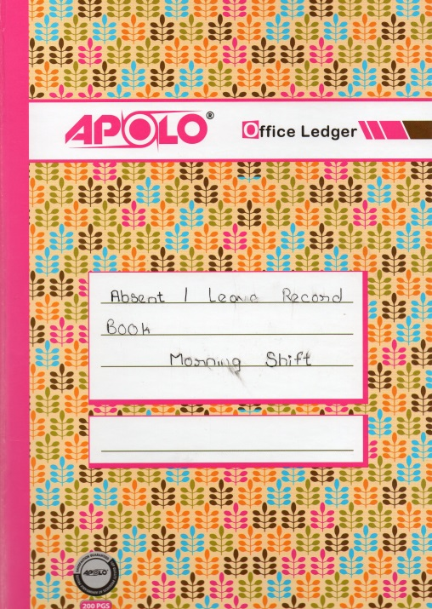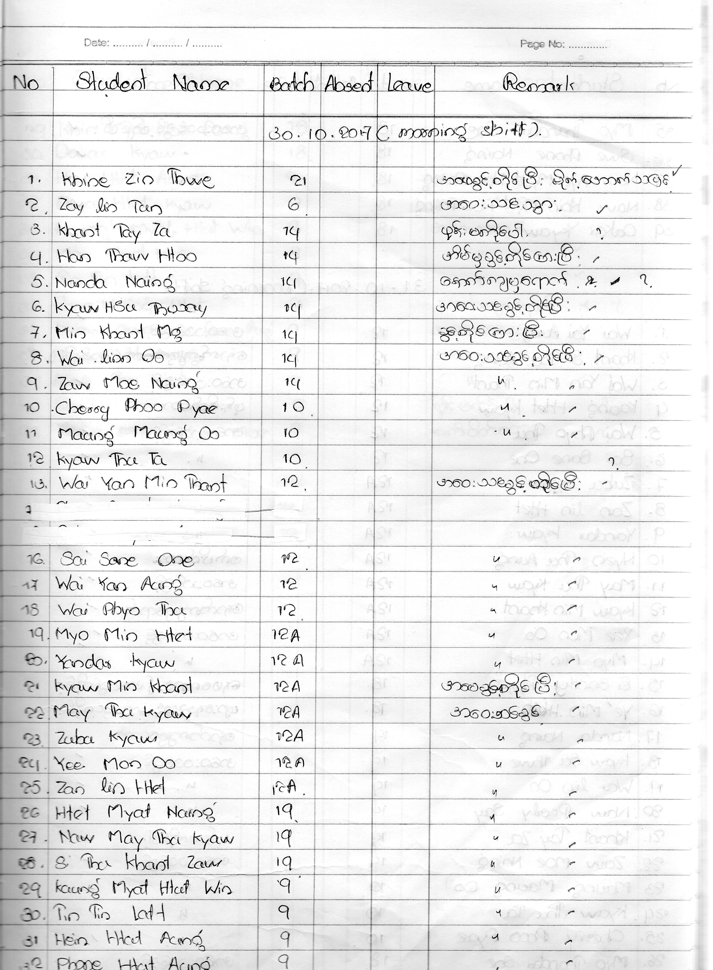

**Figure: 1.2.2 – Daily Attendance Record Book**

Student service record the daily students’ attendance in the “Absent / Leave Record” book. Not only record in the book but also inform to parents.

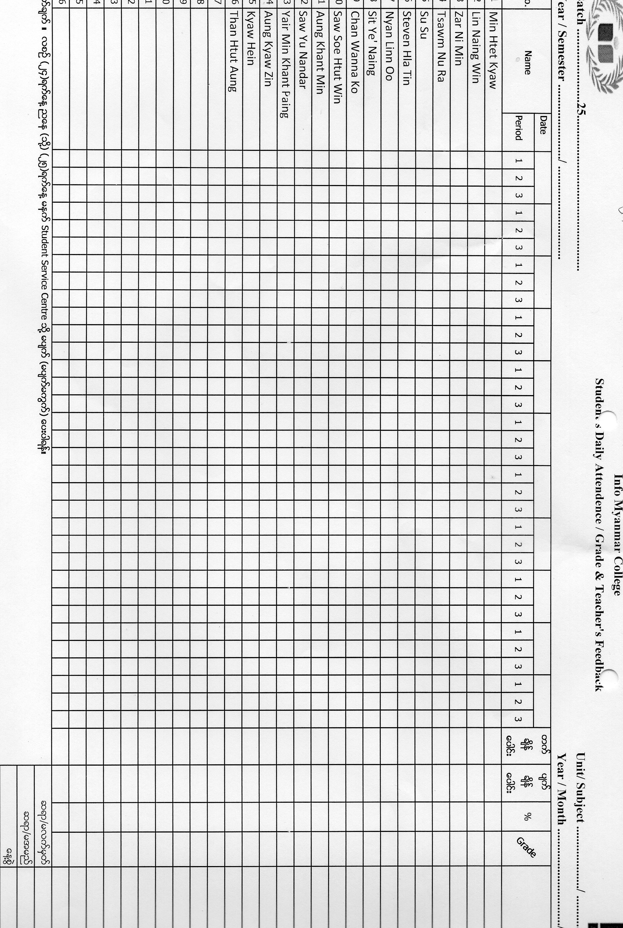

**Figure: 1.2.3 – Daily Attendance Record Form**

The above figure is attendance form which is performed by the teachers. Teachers have to record students’ attendance by class by class. They also record their feedback in the remark. Student service calculates monthly student’s percentage by collecting these forms from the teacher. Therefore teachers have to give these attendance forms to student service in every 25th of month. After that they produce the monthly attendance sheet (Figure: 1.2.4) on the class notice board and also inform to the teacher which students are less percentage.

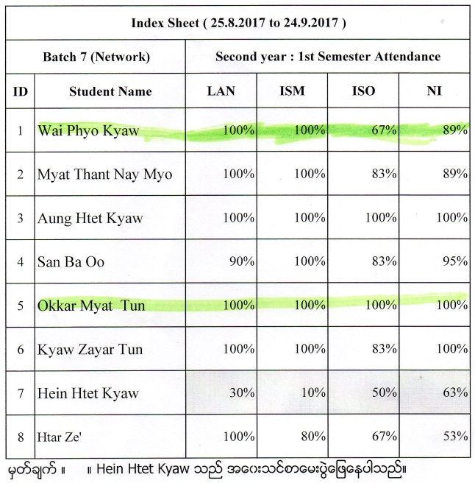

**Figure: 1.2.4 – Students’ Attendance Report**

## 1.2.3 Reporting process

Student service performs reporting process with the student monthly report card by sending to the parents. They insert student’s attendance percentage. Teachers have to give the grade and feedback for the report card. Therefore student service also collects the teachers’ feedback monthly. After that they produce monthly card like below figure.

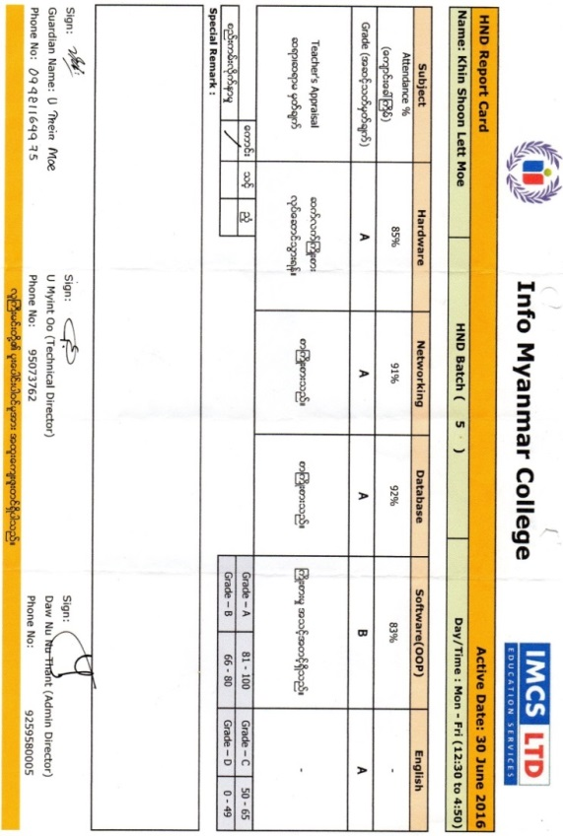

**Figure: 1.2.5 – Monthly Report Card Form**

## 1.2.4 Library process

Student service department support and arrange laptops, uniforms, coffee mugs and lockers for all students individually, including private school ferries for convenient transportation. There have the college library to be convenient, quiet, calm and pleasurable surroundings.

|  |  |
| --- | --- |
| C:\FFOutput\P70327-124659.png | C:\FFOutput\P70327-125531.png |
| **Figure: 1.2.6 – IMC Library** | |

There are over 400 various kinds of books for all round improvement in learning in the library.

### Library Hours

* Monday – Friday: 09:00 am – 3:30 pm
* Saturday, Sunday and Public holidays: Closed

### Rules for borrowing book

* Must be registered member
* Two books for a student within (2) weeks
* Can borrow another books after returning borrowed books.
* (300) kyats per day for overdue book.

Librarian carry out the library issues such as register member, recording book and borrow issues. The following figures are the documentation of library processes.

|  |  |  |
| --- | --- | --- |
| D:\Myint Myat Kaung\2nd year 1st sem Assignment\Unit 30_Information Systems in Organisations\Myint Myat Kaung_ISO(A1)\P70328-143227.jpg | C:\Users\Myint Myat Kaung\Pictures\img033.jpg | C:\Users\Myint Myat Kaung\Pictures\img034.jpg |
| Record books for library issues | Library member card | Borrow issue card |
| **Figure: 1.2.7 – Library Record Books, Member Card and Book Issue Card** | | |

# 1.3 Formulating and Recording two possible outline projects specification

## 1.3.1 Project Scope

Most of educational organizations have to carry out not only educational service processes and also business management processes.

### Educational services process



**Figure: 1.3.1 - Educational services process**

In college level, the following processes are performed as the educational services.

* **Students’ service processes** – These processes include providing information to students for certain things.
* Keeping and editing all the personal details of students. Provide the timetable to students.
* Recording the students’ attendance. Organizing exams and assignments for students.
* Managing every student exams and assignments date properly.
* Providing all the information about students seating plan, exams, assignments, date and time.
* **Communication information service processes** – This process is to perform the managing of students’ personal issues such as leave from college. And provide all information about vacations, events, etc.
* **Library process** – It is responsible for providing books and managing computers for students. Therefore students could easily study and research about anything without any worry. It is also responsible to keep all records of library books.

### Business management processes

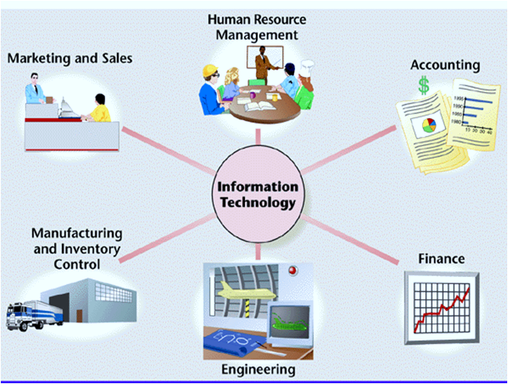

Business Management Process

**Figure: 1.3.2 - Business management processes**

The following are some of the business management processes of Info Myanmar College.

* **Admin** – Administration is the section which controls all other departments of the college business. Their purpose is to take the business out of trouble and trading gainfully. They keep the backup of all the business’s transactions and data. The have full control over business and can take action at any time.
* **Human Resources (HR)** – HR responsibilities include payroll, benefits, hiring, firing, and keeping up to date with state and federal tax laws. Human resource managers straightening the supply of skilled and qualified individuals and the skills of the current workforce, with the organization ongoing and future business plans and requirements to maximize return on investment and secure future survival and success.
* **Finance** – The finance department of a business takes responsibility for organizing the financial and accounting affairs. They record all the financial transactions of the college. The finance department will also be responsible for the technical details of how a business can raise finance, e.g. through loans, shares, etc.
* **Marketing** – Marketing is the most important activity in a business because it has a direct effect on profitability. They deal with the customers to advertise the college information.

According to the above process descriptions, Info Myanmar College requires College Information System to carry out their business functions. Therefore, there can be two possible outline projects specifications that we can develop College Management System for the Educational services process and Office Automation System for the Business management process. In the College Management System project, student registration, attendance, library management, timetable management and information (notice board) systems are included. In the Office Automation System project, employee information, registration, attendance, finance, administration management, human resources management, payment system, sale and marketing, inventory managements systems are included.

## 1.3.2 Time scale

#### College Management System

This project will develop as web application platform by using PHP programming language. Our project teams are well-known about the processes of students’ services. Therefore we can develop the College Management System project within 2 months.

#### Office Automation System

This project will also develop as web application platform like above College Management System project. However our project teams need to know about business processes background such as finance and payment processes. This project will take more duration time than the above project.

## 1.3.3 Resources requirements

As our project is based on web application, we will need IT hardware and software to develop the application. The following facts are some of hardware and software requirements.

#### Hardware resources requirements

* Laptop PCs
* Web Server + Domain
* Printer
* Stationary

#### Software resources requirements

* Sublime Text
* XAMPP
* Libre Office Suite
* Edraw Max
* Adobe Photoshop
* MS Project

2. Identifying the factors of project selection

# 2.1 Feasibility Study of College Management System project and Office Automation System project

For all new systems, the system analysis process starts with feasibility study. The input to the feasibility study is an outline description of the system and how it will be used within an organization. The result of the feasibility study should be are port which recommends whether or not it is worth carrying on with the system analysis process and system development process.

## 2.1.1 Technical feasibility

This is concerned with specifying the technical equipment and the software to satisfy the user requirements. The technical requirements of the system vary considerably but might include:

* The facility to produce outputs in a given time
* Response time under certain conditions
* Ability to process a certain volume of transactions at a specified speed
* Facility to communicate data to a distant location

Technical feasibility centers on the existing computer system, hardware, software etcetera and to what extent it can support the system. In examining the technical feasibility, the configuration of the system is given more importance than the actual hardware. The configuration should provide the complete picture of the system requirements, for example how many workstations are required and how these units are interconnected so that they would operate smoothly, etcetera. The result of the Technical Feasibility Study is the basis for the documents against which dealer and manufacturer can make bids. Specific hardware and software products can then be evaluated keeping in view the logical needs.

Our project (web application) which avoids more manual hours that needs to spend in record keeping and generating reports. This application keeps the date in a centralized way which is available to all the event college principle. It is very easy to manage historical data in database. Participants can register for any happening event from anywhere. Event authorized staff can keep records of students and system can easily inform to students by message and emails. Using this system, staff can easily generate exam result, timetable and report card for the students.

## 2.1.2 Operational feasibility

It determines how acceptable the software is within the organization. The evaluations must then determine the general attitude and skills. Such restriction of the job will be acceptable. To the users are enough to run the proposed budget, hence the system is supposed to the feasible regarding all except of feasibility. In operational feasibility, we attempt to ensure that every user can access the system easily. We develop a menu that users can easily access and we provide shortcut keys.

We show a proper error message when any mistakes are made in the program. We provide help and a guideline menu to help the user.

Changes in the ways individuals are organized into groups may then be necessary and the groups may now compete for economic resources with the needs of stabilized ones by converting a number in a file in software.

## 2.1.3 Financial feasibility

Financial feasibility is the most frequently used method for evaluating the effectiveness of a new system. More commonly known as cost/benefit analysis, the procedure is to determine the benefits and savings that are expected from a candidate system and compare them with costs. If benefits outweigh costs, then the decision is made to design and implement the system.

Using a Gantt chart schedule and PERT chart, we can estimate that the benefit of the project is greater than the cost. Tangible costs are easily estimated. They include the one-time cost of developing the system and the continuous costs of operating the system. Intangible costs are usually not discussed because they are rarely large. So we can develop the project easily then it is used for the evaluation of the proposed. We calculate the cost/benefit analysis and we assume that the benefit is feasible so we start developing the project. It is an analysis of the cost to be incurred in the system and benefits the derivable from the system.

## 2.1.4 SWOT analysis

SWOT is a strategic planning tool used to evaluate the strengths, weaknesses, opportunities, and threats to a project. It involves specifying the objective of the project and identifying the internal and external factors that are favorable and unfavorable to achieving that objective. The strengths and weaknesses usually arise from within an organization, and the opportunities and threats from external sources.

The SWOT analysis is an important part of the project planning process:

* Strengths: attributes of the organization that help achieve the project objective.
* Weaknesses: attributes of the organization that stop achievement of the project objective.
* Opportunities: external conditions that help achieve the project objective.
* Threats: external conditions that could damage the project.

### SWOT analysis of developing web application projects

#### Strength

* Employees gave high marks to IT support staff across campus for their expertise, dedication, flexibility and the quality of service they provided.
* The reliability of the campus network was seen as strength.
* Students praised the availability of computers and said it was easy to find help.
* Students specifically highlighted library services and some online services like Academic Planner, OneStop and Moodle as strengths.

#### Weaknesses

* Participants agreed that a lack of depth in technical staff was cause for concern. There was also acknowledgement that lack of funding for IT was a concern, but perhaps more concerning was a central IT funding model based on largely on telephone and network port charges. Funding levels and stability also create recruitment and retention issues for technical staff.
* Both groups spent considerable time discussing weaknesses related to coordination of central and distributed IT services. The groups pointed to lack of Service Level Agreements (SLAs), lack of standard operating procedures, lack of governance and poor communication as significant weaknesses.
* Lack of effective governance and coordination is tied to IT service delivery and support weaknesses.
* A fourth area of concern was IT strategic planning. Employees expressed concerns about lack of structure and transparency in planning and decision-making,
* Students expressed frustration with inconsistencies in the quality of campus websites, and inconsistencies in technology in computer labs and classrooms. They said that many campus web systems are not user-friendly and are not integrated with each other. And they listed a lack of wireless network coverage in some areas as a significant weakness.

#### Opportunities

* Employees identified opportunities for improving efficiency and reducing costs through economies of scale, collaboration. Employees and students both listed expansion of wireless network access as an opportunity.
* The most significant threat envisioned by faculty, staff and administrators was the challenge of balancing the college’s technology capacity with rapidly rising expectations.
* Students recognized that growing demand for technology creates a threat. They suggested that the rapidly growing range of mobile devices might create a threat to the quality of support. Students also recognized the strain that growing technology demands would place on the college, expressing concerns about budget priorities. Finally, students identified concerns about access to technology in cases of emergencies.

#### Threats

* Security challenges, legal mandates and economic conditions as threats.
* There are many similar web applications in the markets.

### SWOT analysis for Office Automation System

|  |  |
| --- | --- |
| **Strengths (internal factors)** | **Weaknesses (internal factors)** |
| Good reputation among customers  Broad market coverage  Manufacturing competence  Good marketing skills  Good material management systems  Information system competencies  Brand name reputation  Portfolio management skills  Cost of differentiation advantages  New-venture management expertise  Appropriate management style  Appropriate organizational structure  Appropriate control systems  Ability to manage strategic change  Well-developed corporate strategy  Good financial management | Obsolete, narrow product lines  High conflict and politics  Loss of corporate control |
| **Opportunities (external factors)** | **Threats (external factors)** |
| Expand core business  Exploit new market segments  Arrival of new technologies  Removal of international trade barriers  Exploit unfulfilled customer need  Widen new market segments  Extend cost of differentiation advantage  Diversify info new growth businesses  Expand into foreign markets  Apply Research & Development skills in new areas  Enter new related businesses  Overcome barriers to entry  Reduce rivalry among competitors  Make profitable new acquisitions  Apply brand name capital in new areas  Seek fast market growth | Attacks on core business  Increases in domestic competition  Shift in consumer tastes  New regulations  Increase in foreign competition  Change in customer experiences  Environmental factors  Political influences |

### SWOT analysis for College Management System

|  |  |
| --- | --- |
| **Strengths (internal factors)** | **Weaknesses (internal factors)** |
| Processes and systems   * Customer service/ support * Student service/ support * Dedicated staff   Reputation   * Web development services   Resource availability | Timescale and deadlines  Gaps in knowledge and expertise  Budget and funding  Staffing levels  Technology training/ orientation  Communication |
| **Opportunities (external factors)** | **Threats (external factors)** |
| Changing consumer behavior  Technology and infrastructure development  Emerging and developing markets  New innovations (Research & Developmentr)  Market demand | Environmental factors  Political influences |

# 2.2 Critical analyzing of business case for two projects

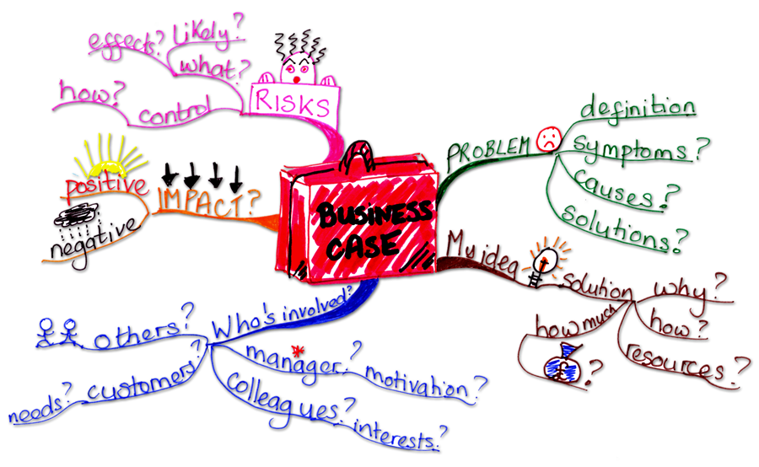

**Figure: 2.1**

The business case is to document the justification for the undertaking of a project usually based on the estimated cost of development and implementation against the risks and the anticipated business benefits and savings to be gained. The total business change must be considered, which may be much wider than just the project development costs. The concept of the business case may exist under other names, e.g. project brief, project charter, high level project plan. Irrespective of the name the purpose is to present justification for project start up and initiation.

In our two projects, we estimate the project benefit and cost. These benefits and costs may be tangible. Because of confusion between the types of costs, it is sometimes very difficult to decide if the benefits outweigh the costs.

Tangible benefits may include decreasing salary costs by automating manual procedures, preventing costly but frequently errors, sending bills earlier in the month, and increasing control over inventory levels. Such benefit may be directly estimated in rupees without much trouble. Intangible benefits may include increasing quality of goods produced, upgrading or creating new customer services, reducing repetitive or monotonous work for employees, and developing a better understanding of the market. Such benefits may be much more important than tangible benefits, but they may be ignored because estimating their rupee values involves pure guesswork.

Tangible costs are easily estimated. They include the one-time cost of developing the system and the continuous costs of operating the system. Example of development costs are the salaries of software engineer, system analysts and other experts, the prices of the computer equipment, and the expenses connected with user training. Operating costs include the salaries of maintenance technician and the cost of computer time and computer supplies. Intangible costs are usually not discussed because they are rarely large. Examples of such costs include those associated with early user dissatisfaction and with the problems of converting to the new system.

Both systems can be developed technically and will be used if installed must still be a good investment. That is, financial benefits must equal or exceed the financial costs. The economic and financial question raised by analysts during the preliminary investigation seeks estimates of:

1. The cost to conduct a full systems investigation.
2. The cost of hardware and software for the class of application being considered.
3. The benefits in the form of reduced costs or fewer costly errors.
4. The cost if nothing changes (the system is not developed).

Cost and benefit estimate on each project provide a basis for determining which projects are most worthy of consideration. Each estimate can be analyzed to determine how rapidly costs are recovered by benefits, to calculate both the absolute and interest-adjusted amounts of excess benefits, and to establish the ratio of benefits to costs. All of these factors are considered when developing an overall sense of the project’s business case.

As both of the College Management System and Office Automation System are developed with same technical platform, most of the resources requirements are also can be same needed. The estimation of a project resources requirements costs are describing the following tables.

**Table: 2.1**

|  |  |  |  |
| --- | --- | --- | --- |
| Man Power | | | |
| No. | **Role** | **Quantity** | **Costs (USD)** |
| 1. | Project Leader | 1 | 300/month |
| 2. | Software Engineer | 1 | 250/month |
| 3. | System Analyst | 1 | 250/month |
| 4. | Web Master | 1 | 200/month |
| 5. | Maintenance | 1 | 150/month |
| Total | | | **1150/month** |
| For 2 months | | | **23000** |

**Table: 2.2**

|  |  |  |  |
| --- | --- | --- | --- |
| Hardware Resources | | | |
| No. | **Description** | **Quantity** | **Costs (USD)** |
| 1. | Web Server + Domain | 1 | Supported by project sponsor |
| 2. | Laptop PC | 3 | 3000 |
| 3. | Printer | 1 | 170 |
| 4. | Stationary and Document paper | - | 50 |
| Total | | | **3220** |

**Table: 2.3**

|  |  |  |  |  |
| --- | --- | --- | --- | --- |
| Software Resources | | | | |
| No. | **Description** | **Quantity** | **Costs (USD)** | |
| 1. | Sublime Text Software | 1 | Free | |
| 2. | XAMPP | 1 | Free | |
| 3. | Libre Office Suite | 3 | Free | |
| 4. | E-draw Max | 1 | 245 | |
| 5. | Adobe Photoshop | 1 | 2 months | 98 |
| Total | | | **343** | |

**Table: 2.4**

|  |  |  |
| --- | --- | --- |
| Other Costs | | |
| No. | **Description** | **Costs (USD)** |
| 1. | Phone Bill | 60/month |
| 2. | Electric Bill | Supported by project sponsor |
| 3. | Water Bill | Supported by project sponsor |
| 4. | Office Room | Supported by project sponsor |
| Total | | 60/month |
| For 2 months | | **120** |

**Table: 2.5**

|  |  |  |
| --- | --- | --- |
| Grand total costs for a project | | |
| No. | **Description** | **Costs (USD)** |
| 1. | Man Power resources | 23000 |
| 2. | Hardware Resources | 3220 |
| 3. | Software Resources | 343 |
| 4. | Other Costs | 120 |
| Grand total | | **26683** |

# 2.3 Project selection method

Project selection methods are the techniques used to execute this process, and they are organized into two major categories: benefit measurement methods and constrained optimization methods.

The project selection methods used by an organization should be relevant to the objectives of the company and its managers and should be consistent with the capabilities and resources of the organization.

|  |  |  |
| --- | --- | --- |
| Method Type | Examples | Notes |
| Benefit measurement (comparative approach) | Scoring models, cost-benefit analysis, review board, economic models. | Benefit measurement is the most common approach. |
| Constrained optimization (mathematical approach) | Linear programming, nonlinear programming, integer programming, dynamic programming, multi-objective programming. | Constrained optimization makes use of math models and complex criteria and is often managed as a distinct project phase. |

# 2.4 Project background



**Figure: 2.2 – IMC Logo**

IMC was established in 2014. It’s one of the educational outlets of IMCS Company Limited since 2008, which achieved the success in the Professional Information Technology Certification Level. Info Myanmar College is the registered center of Pearson Education UK to provide Higher National Diploma Courses.



**Figure: 2.3 – ENU Logo**

Edinburgh Napier University, one of the most prestigious universities in United Kingdom, in partnership with Info Myanmar College, has been proudly brought to all Myanmar students who are ardently studying computing subject.

## 2.4.1 Problem and Opportunities

As most of the college departments’ works are done by manually or they are based on paper work such as class attendance, notes, library dues, asking for documents etc. Now-a-days, education is playing very significant role in the society.

Admissions are increasing day by day so there by ratio of establishment new colleges and schools are also increasing. But the actual challenge is starting from now. Most of the schools and colleges are maintain student information in records. When the number of records increased, it is difficult to maintain the information of each student in the old manual system. Maintaining the records manually leads to error prone and required more man power and it consumes more time for processing the records.

## 2.4.2 The rationale for project selection

According to the results of project select technique and system analysis, the development duration is less than Office Automation System. Moreover our project team needs to take the business functional training to know about the financial process. Therefore the development cost of Office Automation System is more than College Management System.

Currently, Info Myanmar College organization wants to change student service manual system to computerized system more than business management process. Therefore we selected College Management System which is included students’ services functions. After that we will migrate the business department function to the College Management System.

## 2.4.3 Project Overview Statement

|  |  |  |  |  |  |  |  |
| --- | --- | --- | --- | --- | --- | --- | --- |
| **Project Overview Statement** | | | | | | | |
| **Project Name** | | **Team Members** | | | | | |
| College Management System | | D:\Personal MMK\MMK CV\IMG_3118.JPG | | | C:\Users\Myint Myat Kaung\Desktop\20624077_2337305533161521_1475084132_n.jpg | | C:\Users\Myint Myat Kaung\Desktop\11923219_434921070026668_3849268429083725927_n.jpg |
| Myint Myat Kaung  (Project Leader) | | | Myo Pyae Sone Aung  (Software Engineer) | | Kyaw Myo Tun  (System Analyst) |
| **Problem and Opportunities**  Maintaining the records manually leads to error prone and required more man power and it consumes more time for processing the records. | | | | | | | |
| **Project Goal**  The purpose of the project is to automate and centralize the whole system of the student service and teaching departments. We are attempting to improve the college’s existing system that runs on pen and papers. The main goal of the project is to automate the process carried out in the organization with improved performance and realize the vision of paperless works. | | | | | | | |
| **Project Objective**  The main objective of developing the current project entitled “College Management System” is to build effective system which is fast, accurate, consistency, reliable and flexible enough so that it can incorporate any future enhancements. | | | | | | | |
| **Success Criteria**  This system handles online student admission procedure. This project College Management System is a web based project that maintains all the activity related to college. This project provides time to time event information related to college. It also provides the facility for sending mail or message to parents regarding student activity. This system is to managing the student information and faculty details. This project provides privilege facility for security purpose and provide log in facility according to designation and restrict unauthorized used, if user or student is not admin then it can’t access everything, this project provide many type of designation facility and access permission. It can managing generate report according to date and show all report also. They did not store historical information and not possible to view all at a time.  This system reduce the time and cost. It also provides the facility to retrieve student all information according to requirement. It can maintain the college event and all activity related information; latest news display and college related all information display on this project. | | | | | | | |
| **Prepared by** | | | **Lecturer Approved by** | | | **Principle Approved by** | |
| (Sign) | | | (Sign) | | | (Sign) | |
| Name | Myint Myat Kaung | | Name | Dr. Myint Myat Myo | | Name | Daw Nu Nu Thant |
| Date |  | | Date |  | | Date |  |

# 2.5 Organizing the project team

A project team is an organized group of people who are involved in performing shared/individual tasks of the project as well as achieving shared/individual goals and objectives for the purpose of accomplishing the project and producing its results. The team consists of the full-time and part-time human resources supposed to collaboratively work on producing the deliverables and moving the project towards successful completion.



**Figure: 2.4 - Organizing the project team**

Proper project team organization is one of the key constraints to project success. If the project has no productive and well-organized team, there’s an increased probability that this project will be failed at the very beginning because initially the team is unable to do the project in the right manner. Without right organization of teamwork, people who form the team will fail with performing a number of specific roles and carrying out a variety of group/individual responsibilities.

## 2.5.1 Project Team

There are five members to carry out the project development team. They are:

1. Project Leader
2. System Analyst
3. Software Engineer
4. Webmaster
5. Maintenance Technician

The role and responsibilities of each team members are describing following.

## 2.5.2 Role and responsibilities

### 1. Project Leader

A team leader is an important member of a collaborative project team. This individual or group of individuals is responsible for planning, executing and promoting the activities that a project undertakes. The team leader is responsible for:

* Ensure project is developed in line
* Encourage all participants to take an active role in the project
* Ensure participants have a clear understanding of what they need to complete and when
* Drive the project team for on time delivery
* Lead the design, planning and execution validation activities
* Point of contact for members wishing to join and participate in the project.
* Set-up and management of team meetings
* Organize any necessary meetings to progress team work (weekly, daily, or ad-hoc as appropriate)
* Plan and execute meetings at action week and any other face-to-face meetings as required.
* Define and manage team structure and associated modifications
* Assign team responsibilities
* Manage delivery of the agreed roadmap items, specifically as applies to the project and outlined within the charter.
* Monitor progress and manage risks to and recovery of any schedule slippages
* Owner and principal editor for the team charter including oversight of any sub-team charters.

The project team member Mr. Myint Myat Kaung will perform as the project leader. He will lead and manage the project team. He has responsible to carry out the project planning, calculating the project costs and etc.

### 2. System Analyst

A systems analyst is an IT professional who works on a high level in an organization to ensure that systems, infrastructures and computer systems are functioning as effectively and efficiently as possible. System analysts carry the responsibilities of researching problems, finding solutions, recommending courses of actions and coordinating with stakeholders in order to meet specified requirements.

Systems analysts transform user requests or requirements into technical design specifications and act as a liaison between clients/IT professionals and technology vendors. The main responsibility of systems analysts in the IT industry is to figure out how to solve a problem by linking different computers or systems and to specify what platform, protocols, software, hardware and communications medium can be used to solve that problem. The job’s responsibilities may be summarized as follows:

* Communicate with customers and stakeholders to learn and document requirements in order to create a technical specification
* Interact and coordinate with developers and implementers
* Help perform system testing
* Deploy the system
* Help with technical documentation like manuals
* Deliberate over post-project assessment

For this role, Mr. Kyaw Myo Tun will perform as system analysis. He has responsible to list the client requirements, interview notes and etc.

### 3. Software Engineer

Software engineer is an excellent career choice for a person who excels at both left and right-brained thinking - analytic and numerical skills in addition to conceptual problem-solving skills. Software engineers are innate problem-solvers, good at collaboration and keen to see an issue through to successful completion. Some responsibilities of a software engineer are:

* Execute full software development life cycle (SDLC)
* Develop flowcharts, layouts and documentation to identify requirements and solutions
* Write well-designed, testable code
* Produce specifications and determine operational feasibility
* Integrate software components into a fully functional software system
* Develop software verification plans and quality assurance procedures
* Document and maintain software functionality
* Troubleshoot, debug and upgrade existing systems
* Deploy programs and evaluate user feedback
* Comply with project plans and industry standards
* Ensure software is updated with latest features

To carry out the above responsibilities, Mr. Myo Pyae Sone Aung will perform as the Software Engineer.

### 4. Webmaster

A webmaster is in charge of maintaining Web sites for companies and individuals on the World Wide Web. This is a job that requires a wide range of skills and abilities, since many webmasters must do much more than simply write computer codes or update links to other Web sites. The webmaster is ultimately responsible for ensuring that a Web site is easy to navigate and that it addresses the needs of the client and its customers. The webmaster responsibilities are:

* Maintain websites for clients and businesses.
* Ensure the web servers, hardware and software are operating accurately.
* Design websites.
* Generate and revise web pages.
* Examine and analyze site traffic.
* Utilize scripting languages such as JavaScript.
* Configure web servers such as Apache.
* Serve as the server administrator.
* Regulate and manage access rights of different users on website.
* Create and modify appearance and setting of site.
* Lay out content on web pages.
* Deal with and respond to heavy volumes of email.
* Decide what kind of computer will hold a web site's information.
* Test websites to see if there are any parts that are difficult to use.
* Meet with designers to agree on site's design.
* Fix links that don't work and pictures that aren't appearing properly.
* Decide how site's content will be delivered to the Internet.
* Keep files small so sites load faster.
* Test different browsers and ensure people with different computers can access a website.

### 5. Maintenance Technician

The computer and network maintenance technician is responsible for supporting the organization’s computing and telecommunication network operations and procedures. The technician works within a team environment to support telephone systems, which includes installation of cabling and phones, maintenance of the phone switch and voice mail, and customer service activities. The position is responsible for peripheral equipment, networks, communications equipment, and providing support for users’ software and hardware needs.

* Troubleshoot, repair, maintain, installs and performs testing activities on various computer equipment, peripherals, data communication and computer network systems.
* Assembles, installs, configures and tests computer equipment or units of local area networks requiring use of standard interface protocols.
* Completes work orders such as installing equipment, connecting and moving devices or creating components of autonomous networks, installing disk drives and correcting definitions on data switches, protocol converters, etc.
* Develops and maintains software and hardware inventory and tracking systems, develops inventory lists and orders, stocks and stores electronic components.
* Installs cable for phone system. Performs moves, add, delete and other changes for phone uses.
* Configures and sets up servers to work with various programs, installs software. Ensures server backups and networked user backups are performed on a regular basis.
* Performs preventive maintenance for computer, data communication and peripheral equipment, tests and adjusts to appropriate standards.

## 2.5.3 Linear Responsibility Chart

**Table: 2.5.0**

|  |  |  |  |  |  |  |  |  |  |  |  |  |  |  |  |  |  |  |
| --- | --- | --- | --- | --- | --- | --- | --- | --- | --- | --- | --- | --- | --- | --- | --- | --- | --- | --- |
| |  |  | | --- | --- | | Number Reference | | | 1 | Actual responsibility | | 2 | General supervision | | 3 | Must be consulted | | 4 | May be consulted | | 5 | Must be notified | | 6 | Final approval | | Info Myanmar College | Mr. Myint Myat Kaung | Mr. Kyaw Myo Tun | Mr. Myo Pyae Sone Aung |
|  | D:\Personal MMK\MMK CV\IMG_3118.JPG | C:\Users\Myint Myat Kaung\Desktop\11923219_434921070026668_3849268429083725927_n.jpg | C:\Users\Myint Myat Kaung\Desktop\20624077_2337305533161521_1475084132_n.jpg |
| Project Sponsor/ Client | Project Leader | System Analyst | Software Engineer |
| Interview notes | 1 | 3 | 1 | 3 |
| Requirement catalogue | 3 | 5 | 1 | 3 |
| Establish project plan | 6 | 1 | 2 | 2 |
| Define WBS |  | 1 | 2 | 5 |
| Establish hardware specs |  | 3 | 2 | 1 |
| Establish software specs |  | 3 | 2 | 1 |
| Define documentation |  | 1 | 4 | 4 |
| Prepare labor estimate | 5 | 1 | 3 | 3 |
| Prepare equipment cost estimate | 5 | 1 | 3 | 2 |
| Prepare material costs | 5 | 1 | 2 | 2 |
| Make program assignments |  | 1 | 2 | 5 |
| Establish time schedule | 5 | 1 | 3 | 5 |
| Use case diagram |  | 6 | 2 | 1 |
| Package review |  | 6 | 2 | 1 |
| Report text | 5 | 6 | 1 | 3 |
| Report illustrations |  | 6 | 1 | 3 |
| Report appendices |  | 6 | 1 | 3 |

3. Project specification for College Management System project

# 3.1 Functional requirements for College Management System

In our College Management System will include the following project specification.

**Manage students**

* Student registration
* Promote a student from one class to another
* Ability to choose which students get promoted and who are not
* Promote students to a new academic session
* Ability to have a look at student’s results while promoting

**Manage parents**

* Add/edit/delete parents
* Assign parents to student
* A parent can be associated with multiple children

**Manage teachers**

* Add/edit/delete teachers anytime
* Assign teacher to specific class or section

**Manage class**

* Add sections to a class
* Ability to assign teacher for a section
* Multiple sections under a certain class

**Manage subject**

* Add subjects for each class separately
* Assign a teacher for a subject

**Manage timetable**

* Manage class and teacher timetables class-wise
* Change timetable when required
* Specify exam dates
* Add or remove any exam anytime

**Manage attendance**

* Take attendance of students daily
* Keep track if students are absent
* Ability to print the attendance report

**Manage exam, assignment and report card**

* Specify exam and assignment dates
* Add or remove any exam anytime
* Evaluate or put exam marks for each student subject wise
* Compare students’ marks
* Print student result
* Ability to print the monthly report card

**Library management**

* Organize books class-wise
* Students can issue the books they need
* Librarian can keep track of the books issued

## 3.2.1 Data Dictionaries for College Management System

**Table: 3.1**

|  |  |  |  |  |  |
| --- | --- | --- | --- | --- | --- |
| Table Name | Attribute Name | Contents | Data Type | Required | PK or FK |
| Roles | uRole\_id | User Roles ID | INT | YES | PK |
| u\_Role | User Role | VARCHAR | YES |  |
|  | | | | | |
| Users | user\_id | User ID | INT | YES | PK |
| user\_name | User Name | VARCHAR | YES |  |
| user\_Email | User Email | VARCHAR | YES |  |
| user\_Password | User Password | VARCHAR | YES |  |
| ConPassword | Confirm Password | VARCHAR | YES |  |
| user\_Role | User Role | VARCHAR | YES |  |
|  | | | | | |
| Classes | class\_id | Class ID | INT | YES | PK |
| class\_Name | Class Name | VARCHAR | YES |  |
|  | | | | | |
| Major | major\_id | Major ID | INT | YES | PK |
| major\_name | Major Name | VARCHAR | YES |  |
|  | | | | | |
| Parents | parent\_id | Parent ID | VARCHAR | YES | PK |
| parent\_name | Parent Name | VARCHAR | YES |  |
| user\_id | User ID | INT | YES | FK |
| parent\_Email | Parent Email | VARCHAR | YES |  |
| parent\_NRC | Parent NRC | VARCHAR | YES |  |
| parent\_Phone | Parent Phone | VARCHAR | YES |  |
| parent\_Photo | Parent Photo | VARCHAR |  |  |
| parent\_Active | Active status | Boolean | YES |  |
|  | | | | | |
| Students | student\_id | Student ID | VARCHAR | YES | PK |
| parent\_id | Parent ID | VARCHAR | YES | FK |
| major\_id | Major ID | VARCHAR | YES | FK |
| user\_id | User ID | INT | YES | FK |
| student\_name | Student Name | VARCHAR | YES |  |
| student\_DOB | Student DOB | DATE | YES |  |
| student\_gender | Student Gender | VARCHAR | YES |  |
| student\_address | Student Address | VARCHAR | YES |  |
| student\_phone | Student Phone | VARCHAR | YES |  |
| student\_email | Student Email | VARCHAR | YES |  |
| student\_photo | Student Photo | VARCHAR |  |  |
| student\_Active | Active status | Boolean | YES |  |
|  | | | | | |
| Departments | deparments\_id | Deparments ID | INT | YES | PK |
| deparments\_name | Deparments Name | VARCHAR | YES |  |
|  | | | | | |
| Employee Roles | eRole\_id | Employee Roles ID | INT | YES | PK |
| e\_Role | Employee Roles | VARCHAR | YES |  |
|  | | | | | |
| Employees | employee\_id | Employee ID | VARCHAR | YES | PK |
| department\_id | Department ID | INT | YES | FK |
| employee\_name | Employee Name | VARCHAR | YES |  |
| eRole\_id | Employee Role ID | INT | YES | FK |
| user\_id | User ID | INT | YES | FK |
| employee\_DOB | Employee DOB | DATE | YES |  |
| employee\_Gender | Employee Gender | VARCHAR | YES |  |
| employee\_Address | Employee Address | VARCHAR | YES |  |
| employee\_phone | Employee Phone | VARCHAR |  |  |
| employee\_email | Employee Email | VARCHAR |  |  |
| employee\_photo | Employee Photo | VARCHAR |  |  |
| employee\_Active | Active Status | BOOLEAN | YES |  |
|  | | | | | |
| Class Timetables | cTime\_id | Class Timetable ID | INT | YES | PK |
| class\_id | Class ID | INT | YES | FK |
| cTime\_year | Class Timetable Year | VARCHAR | YES |  |
| cTime\_day | Class Timetable Day | VARCHAR | YES |  |
| time\_one | Subject One | VARCHAR | YES |  |
| time\_three | Subject Two | VARCHAR | YES |  |
| time\_three | Subject Three | VARCHAR | YES |  |
|  | | | | | |
| Teacher Timetables | tTime\_id | Teacher Timetable ID | VARCHAR | YES | PK |
| employee\_id | Employee ID | VARCHAR | YES | FK |
| Day | Day | VARCHAR | YES |  |
| time\_one | Time One | VARCHAR | YES |  |
| time\_two | Time Two | VARCHAR | YES |  |
| time\_three | Time Three | VARCHAR | YES |  |
| time\_four | Time Four | VARCHAR | YES |  |
| time\_five | Time Five | VARCHAR | YES |  |
| time\_six | Time Six | VARCHAR | YES |  |
|  | | | | | |
| Subjects | subject\_id | Subject ID | INT | YES | PK |
| subject\_name | Subject Name | VARCHAR | YES |  |
| subject\_QCF | Subject QCF Level | VARCHAR | YES |  |
| subject\_CV | Subject Credit Value | VARCHAR | YES |  |
|  | | | | | |
| Student Attendances | sAtt\_id | Student Attendances ID | INT | YES | PK |
| subject\_id | Subject ID | INT | YES | FK |
| class\_id | Class ID | INT | YES | FK |
| sAtt\_month | Student Attendances Month | VARCHAR | YES |  |
| s\_Percentage | Student Percentage | VARCHAR | YES |  |
|  | | | | | |
| T\_Attendances | eAtt\_id | Employee Attendances ID | INT | YES | PK |
| employee\_id | Employee ID | VARCHAR | YES | FK |
| eAtt\_month | Employee Attendances Month | VARCHAR | YES |  |
| eAtt\_percentage | Employee Attendances Percentage | VARCHAR | YES |  |
|  | | | | | |
| Report Cards | reportCard\_id | Report Card ID | INT | YES | PK |
| student\_id | Student ID | VARCHAR | YES | FK |
| sAtt\_id | Student Attendance ID | INT | YES | FK |
| active\_date | Active Date | DATE | YES |  |
| Grade | Grade | VARCHAR | YES |  |
| teacherRemark | Teacher Remark | VARCHAR | YES |  |
| disGrade | Discipline Grade | VARCHAR | YES |  |
| specialRemark | Special Remark | VARCHAR | YES |  |
|  | | | | | |
| Books | book\_id | Book ID | VARCHAR | YES | PK |
| book\_Name | Book Name | VARCHAR | YES |  |
| author\_Name | Author Name | VARCHAR | YES |  |
| book\_Category | Book Category | VARCHAR | YES |  |
| book\_Location | Book Loacation | VARCHAR | YES |  |
| book\_issued | Book Issued | VARCHAR | YES |  |
| reg\_Date | Register Date | DATE | YES |  |
|  | | | | | |
| Issues | issue\_id | Issue ID | VARCHAR | YES | PK |
| user\_id | User ID | INT | YES | FK |
| book\_id | Book ID | VARCHAR | YES | FK |
| borrow\_date | Borrow Date | DATE | YES |  |
| return\_date | Return Date | DATE | YES |  |
| today\_date | Today Date | DATE | YES |  |
| late\_days | Late Days | VARCHAR | YES |  |
| overdue\_Fee | Overdue Fee | VARCHAR | YES |  |
|  | | | | | |
| Results | result\_id | Result ID | INT | YES | PK |
| student\_id | Student ID | VARCHAR | YES | FK |
| subject\_id | Subject ID | INT | YES | FK |
| result\_Grade | Result Grade | VARCHAR | YES |  |

## 3.1.2 Data Flow Diagram of College Management System



**Figure: 3.1 – Context Diagram**

































**Figure: 3.2 – Data Flow Diagram**

## 3.1.3 ER Diagram for College Management System

**Figure: 3.3 – ER Diagram**

# 3.2 Non-functional requirements for College Management System

## 3.2.1 Performance requirements

The proposed system that we are going to develop will be use as the chief performance system for providing help to the department in managing the whole database of the student studying in the department. Therefore, it is expected that the database would perform functionally all the requirement that are specified.

* The system should be easy to handle
* System should give expected performance results
* The response time should be less

## 3.2.2 Security requirement

We are going to develop a secured database. There are different categories of the users namely administrator, restricted users who will view either all or some specific information from the database.

Depending upon the category of the user access rights is decided. It means if the user is an administrator the he can be able to modify the data, append etc. All other user have the rights to retrieve the information about database.

## 3.2.3 Safety requirement

The database may get crashed at any time certain time due to virus or OS failure. Therefore, it is required to take the database backup.

# 3.3 Constraints

A constraint is a condition, agency or force that impedes progress towards an objective or goal. Constraints should be identified, and described in as much detail as possible during the early stages of a project, so that awareness of them and their potential impact can be managed. This includes understanding the dynamics of the project, and how different constraints interrelate.

There are a number of different types of constraint that can affect construction projects. They are:

* **Design constraints** – Design constraints are factors that limit the range of potential design solutions. For our project, we need to expert in creating web application design.
* **Technical constraints –** Technical constraints generally refer to the processes involved in completing construction activities, and are often based on the practicality of developing methods and standards. To develop our project, we need highly well known the PHP programming language. This project is the new project development. So we have no experience to develop this project. Moreover we have to know about the knowledge of website publishing and cyber security issues.
* **Economic constraints** – Economic constraints relate to the project budget and the allocation of resources. For our project, there can be less in financial problem because our project commits to provide enough budgets when we need more.
* **Management constraints –** These can include particular shift patterns, overtime requirements, resource allocation, safety procedures, working practices, and so on. As most of our project team members less experiences in the web site publishing. Therefore we decide to hire web master and maintenance technician.
* **Time constraints** – These include key dates on the project schedule or project milestones. This constraint is the main constraint for our project because this project is the first experience for us. Therefore we can be overdue date in this project because there can be unexpected process during project development.

# 3.4 Timescales

Our project has five functional requirements. So we divide four timescales in two month durations.

**Table: 3.2**

|  |  |
| --- | --- |
| Functions | Duration |
| Student Information System | 2 weeks |
| Class Timetable Management | 2 weeks |
| Exam System | 2 weeks |
| Library System | 1 weeks |
| Verification and testing | 1 week |

# 

# 3.5 Fitness-for-purpose

Info Myanmar College needs to change the colleges’ manual daily process into computerized system. Our project team researches the IMC’s daily manual process and then we change into computerized system. We change the student registration system, student attendance, and exam system and library process into computerized system. We can fix the IMC’s requirements with College Management System.

# 3.6 Project impacts

## 3.6.1 Legislation

We agree with Info Myanmar College to develop the project. The project agreements include that we will protect the Info Myanmar College’s confidential and registered data with data protection and copyright law.

## 3.6.2 Ethics

As we will develop the College Management System web application of Info Myanmar College, we have responsibilities to protect the and not to be misusing. We focus on data protection because data are very important things for colleges’ process. And then our project teams members are very friendly, trust, respect each other. We will perform the project developing by making group discussion meeting.

## 3.6.3 Sustainability considerations

For College Management System web application, we will hire an webmaster who expertise in website server service to maintain, check the web server regularly daily and fix the error in time.

In the future, we will improve our project by implementing Fee Payment System, HRD System, Pay Roll System, Accounting System, Inventory, Transportation System, Hostel System and Contact Message System. We believe that our project can use in the other Universities and Colleges. We developed as a part of the project wok has the ability to be upgraded and enhancement to meet the newer requirement of the organization that may be arise in future.

4. Producing Project plan for College Management System

# 4.1 Work Breakdown Structure (WBS) for College Management System



**Figure: 4.1 – Work Breakdown Structure**

# 4.2 Project plan of College Management System

## 4.2.1 Project Overview

The College Management System project is a web based project that maintains student service processes of the Info Myanmar College. This project provides time to time event information related to college. This system is to be managing the student information and faculty details.

This project provides privilege facility for security purpose and provides login facility according to designation and restrict unauthorized used, if user or student is not admin then it cannot access everything, this project provide many types of designation facility and access permission. It can managing generate report according to date and show all report also. They did not store historical information and not possible to view all at a time. This system reduces the time and cost and provides the facility to retrieve student all information according to requirement.

It can also maintain the college event and all activity related information, latest news display and college related all information, latest news display and college related all information display on this project. In today modern rush hour of the life, it is difficult for parents to go to college of their children every time a teacher calls. But this College Management System, it can easier for parents and teachers to be in touch every day. As a matter of fact, it can also easier for each individual person who is associated with the system to be in touch as per needed.

## 4.2.2 Project Goal

Hence we conclude that the College Management System would definitely help the user by saving time and effort by reducing the processing time and volume of errors. The efficiency of the work done would be improved and work satisfaction on the part of the employees after computerization would definitely on high.

Functionalities provided by College Management System are as follows:

* Provides the searching and managing facilities based on various factors. Such as student attendance, students’ information (class timetable, notice, report card, etc.).
* Shows the information description of the exam and assignment results
* Editing, adding and updating of records is improved which results in proper resource management of College Management System data.
* Manage the information of college activity.
* Managing the library issue.

Report Generation:

* Generates the report and print out for student attendance, college expenditures
* Mailing students’ report card to the parents.

## 4.2.3 Milestones

We check the progress completion of the project according to the work breakdown structure which is described. There have five main milestones. We review our project progress at the end of each main topic.

## 4.2.4 Organization and responsibilities

We already described about the role and responsibilities of the project team in task (2.5).

## 4.2.5 Monitoring progress

We will describe about monitoring progress at the next task (6).

## 4.2.6 Quality control check list

### Content

**Table: 4.1**

|  |  |  |  |  |  |
| --- | --- | --- | --- | --- | --- |
| No. | Attribute | Yes | No | Null | Remark |
| 1. | Is all text free from spelling error? |  |  |  |  |
| 2. | Does the page utilize the space effectively? |  |  |  |  |
| 3. | Has all the sample data and dummy text been removed? |  |  |  |  |
| 4. | Is there anything missing from the content? |  |  |  |  |
| 5. | Is there duplicate or extraneous content anywhere? |  |  |  |  |
| 6. | Are there strong, noticeable calls to action? |  |  |  |  |
| 7. | Is everything logically laid out and intuitive? |  |  |  |  |
| 8. | Is the tone appropriate for the content and client? |  |  |  |  |
| 9. | Does the page utilize the space effectively? |  |  |  |  |
| 10. | Are there opportunities to cross promote content of to draw visitors to the primary call to action or another section? |  |  |  |  |
| 11. | Is the content placement consistent? |  |  |  |  |

### Design

**Table: 4.2**

|  |  |  |  |  |  |
| --- | --- | --- | --- | --- | --- |
| No. | Attribute | Yes | No | Null | Remark |
| 1. | Is the text easy to read? |  |  |  |  |
| 2. | Are images high qualities and placed appropriately? |  |  |  |  |
| 3. | Is there a clear hierarchy of text and headlines? |  |  |  |  |
| 4. | Is the spacing appropriate and consistent form section to section and element to element? |  |  |  |  |
| 5. | Is the site well designed in terms of alignment, proportions, spacing and color matching? |  |  |  |  |
| 6. | Is the formatting and design consistent throughout the site? |  |  |  |  |
| 7. | Does the design work on phones and tablets? |  |  |  |  |
| 8. | Are long text blocks broken up with subheads and made appealing with bullet points, bold words or other text differentiators? |  |  |  |  |
| 9. | Have the pages & content formatting been tested for client input? |  |  |  |  |
| 10. | Has the “favicon” been created and does it display correctly? |  |  |  |  |
| 11. | Does the live website match the mockup? |  |  |  |  |

### Functionality

**Table: 4.3**

|  |  |  |  |  |  |
| --- | --- | --- | --- | --- | --- |
| No. | Attribute | Yes | No | Null | Remark |
| 1. | Does the responsive design work on all pages? |  |  |  |  |
| 2. | Do the links and buttons stand out? |  |  |  |  |
| 3. | Do external links and PDFs open in a new tab? |  |  |  |  |
| 4. | Has the site been tested in all major browsers? |  |  |  |  |
| 5. | Have the site files and database been backed up and stored in a safe place? |  |  |  |  |
| 6. | Does the website function as needed, and is it easy to use? |  |  |  |  |
| 7. | Have all the links been double checked? |  |  |  |  |
| 8. | Has the site usability been tested on various devices(desktop, tablet, phone)? |  |  |  |  |
| 9. | Does the work function work properly? |  |  |  |  |
| 10. | Does the “404 page” help users find the appropriate information to fix the error? |  |  |  |  |

### Security

**Table: 4.4**

|  |  |  |  |  |  |
| --- | --- | --- | --- | --- | --- |
| No. | Attribute | Yes | No | Null | Remark |
| 1. | Has a custom user name been created other than “admin” or “administrator”? Was user ID=1 removed from the database? Has a user “nickname” been created to display on the front end? |  |  |  |  |
| 2. | Is the password for College Management System (CMS) secure, including letters, numbers and special characters with no English words? |  |  |  |  |
| 3. | Has the login page been changed to something other than /wp-admin to protect from brute force attacks? Is there a limit on failed login attempts? |  |  |  |  |
| 4. | Are there captcha fields on the forms to limit spammers? |  |  |  |  |
| 5. | Have only stable, secure third-party plug-ins and versions of jQuery been used? Have all unused plug-ins been deleted? |  |  |  |  |
| 6. | Are the plug-ins, CMS and themes up to date? Is the CMS version information hidden? |  |  |  |  |
| 7. | Have the database table prefix and authentication keys been changed? |  |  |  |  |
| 8. | Is the password for the database secure? Have weekly database backups been scheduled? |  |  |  |  |
| 9. | Are the file and folder permissions set to restrict access? Are users prevented from executing PHP from the uploads folder? |  |  |  |  |
| 10. | Is directory browsing prevented? |  |  |  |  |

### Form

**Table: 4.5**

|  |  |  |  |  |  |
| --- | --- | --- | --- | --- | --- |
| No. | Attribute | Yes | No | Null | Remark |
| 1. | Have forms been tested thoroughly in all browsers and devices? |  |  |  |  |
| 2. | Are the forms intuitive and easy to fill out? |  |  |  |  |
| 3. | Can the text being inputted be easily read? |  |  |  |  |
| 4. | Have required and validated fields been tested? What happens when someone enters information incorrectly? Is it clear what is required of them? |  |  |  |  |
| 5. | Have “thank you” pages been created for each form? |  |  |  |  |
| 6. | Are the form instructions clear, and do they contain all the necessary information? |  |  |  |  |
| 7. | Are forms being sent to the correct recipient? |  |  |  |  |
| 8. | Does the reply from that email work properly? |  |  |  |  |

### Search Engine Optimization

**Table: 4.6**

|  |  |  |  |  |  |
| --- | --- | --- | --- | --- | --- |
| No. | Attribute | Yes | No | Null | Remark |
| 1. | Has Google Analytics tracking been installed and confirmed to be operational? |  |  |  |  |
| 2. | Has the site been optimized with page titles, keywords and meta descriptions? |  |  |  |  |
| 3. | Have “301 redirects” been used for any URLs that are removed? |  |  |  |  |
| 4. | Has the site been tested for page load time? |  |  |  |  |
| 5. | Are “pretty permalinks” being used? (the URLs should use real words rather than query strings). |  |  |  |  |
| 6. | Has a dynamic sitemap been created and submitted to Google Webmaster? |  |  |  |  |
| 7. | Are animations Javascript (rather than flash)? Can you see everything on an iPad |  |  |  |  |
| 8. | Is all the main text “live text” rather than image-based text? If you’re not sure, try to copy and paste it. |  |  |  |  |

## 4.2.7 Project task description

We will describe about project task at the next task (6).

## 4.2.8 Project schedule

We will describe about project schedule at the next task (6).

5. Matching resources efficiently to the College Management System project

# 5.1 Listing of resources for College Management System

## 5.1.1 Work resources

|  |  |
| --- | --- |
| Project Sponsor/ User | Info Myanmar College is an educational organization. This college will be not only project sponsor but also as user. They will provide the budget, work place and other requirements such phone, water and electric bills during project performing. We will get the data and information from the college office and departments to do requirements gathering. |
| Info Myanmar College |

**Table: 5.1**

|  |  |  |  |
| --- | --- | --- | --- |
| Man Power | | | |
| No. | **Role** | **Quantity** | **Costs (USD)** |
| 1. | Project Leader | 1 | 300/month |
| 2. | Software Engineer | 1 | 250/month |
| 3. | System Analyst | 1 | 250/month |
| 4. | Web Master | 1 | 200/month |
| 5. | Maintenance | 1 | 150/month |
| Total | | | **1150/month** |
| For 2 months | | | **23000** |

## 5.1.2 Material resources

|  |  |
| --- | --- |
| Hardware resources | Utilization Description |
| D:\Myint Myat Kaung\2nd year 2nd sem Assignment\Unit 4_Project Design Implementation and Evaluation\Myint Myat Kaung_PDIE (A1)\Laptop-PNG-Image.png  Laptop PC | We need laptop PCs to use required software and implement the project application and documentation. We can get laptop PC from our project sponsor IMC. |
| D:\Myint Myat Kaung\2nd year 2nd sem Assignment\Unit 4_Project Design Implementation and Evaluation\Myint Myat Kaung_PDIE (A1)\PowerEdge-R230-Rack-Server-3.jpg  Web Server + Domain | As we will develop the web application, we need a web server to perform the application on the web service. We also need a domain to access on the website. Therefore our project sponsor will provide these requirements. |
| Image result for epson printer png  Printer | We will need a printer to produce documentation. |
| Image result for stationary png  Stationary | Stationary things and paper are needed. |

|  |  |
| --- | --- |
| Software resources | Utilization Description |
| Image result for sublime text logo png  Sublime text | Sublime Text is a sophisticated text editor for code, markup and prose. We will implement the project application coding by using Sublime text. |
| Image result for XAMPP  logo png  XAMPP | XAMPP is a free and open source cross-platform web server solution stack package developed by Apache Friends, consisting mainly of the Apache HTTP Server, MariaDB database, and interpreters for scripts written in the PHP and Perl programming languages. We will install XAMPP on a PC to use Apache and PhpMyAdmin service. |
| Image result for Libre Office Suite logo png  Libre Office Suite | Libre Office is a free and open source office suite, a project of The Document Foundation. We will make documents writing in our project by using this office software. |
| Image result for E-draw Max logo png  Edraw Max | We will use Edraw Max software that is a 2D business technical diagramming software which help create flowcharts, organizational charts, mind map, network diagrams, floor plans, workflow diagrams, business charts, and engineering diagrams. |
| Image result for Adobe Photoshop logo png  Adobe Photoshop | Adobe Photoshop is the predominant photo editing and manipulation software. We will use this software to edit photo or logo for web design. |

## 5.1.3 Cost resources

**Table: 5.1.1**

|  |  |  |  |
| --- | --- | --- | --- |
| Hardware Resources | | | |
| No. | **Description** | **Quantity** | **Costs (USD)** |
| 1. | Web Server + Domain | 1 | Supported by project sponsor |
| 2. | Laptop PC | 3 | 3000 |
| 3. | Printer | 1 | 170 |
| 4. | Stationary and Document paper | - | 50 |
| Total | | | **3220** |

**Table: 5.1.2**

|  |  |  |  |  |
| --- | --- | --- | --- | --- |
| Software Resources | | | | |
| No. | **Description** | **Quantity** | **Costs (USD)** | |
| 1. | Sublime Text Software | 1 | Free | |
| 2. | XAMPP | 1 | Free | |
| 3. | Libre Office Suite | 3 | Free | |
| 4. | E-draw Max | 1 | 245 | |
| 5. | Adobe Photoshop | 1 | 2 months | 98 |
| Total | | | **343** | |

**Table: 5.1.3**

|  |  |  |
| --- | --- | --- |
| Other Costs | | |
| No. | **Description** | **Costs (USD)** |
| 1. | Phone Bill | 60/month |
| 2. | Electric Bill | Supported by project sponsor |
| 3. | Water Bill | Supported by project sponsor |
| 4. | Office Room | Supported by project sponsor |
| Total | | 60/month |
| For 2 months | | **120** |

**Table: 5.1.4**

|  |  |  |
| --- | --- | --- |
| Grand total costs for a project | | |
| No. | **Description** | **Costs (USD)** |
| 1. | Man Power resources | 23000 |
| 2. | Hardware Resources | 3220 |
| 3. | Software Resources | 343 |
| 4. | Other Costs | 120 |
| Grand total | | **26683** |

# 5.2 Resources Arrangements

We have a plan to train our team members for their skill improvement and easily to use the hardware and software. So we have trainee time for our team members to improve their skills and knowledge.

In our project team we have five project members. They are project leader, software engineer, system analyst, webmaster and system maintenance. In now we have a problem to use the resources and allocate the resources. Software engineer and webmaster have not any problem to use the web server and domain. But, our system analyst has some problem to use the web server.

Another problem is all of our project members are unfamiliar with the software resources. We do not have much time to solve this problem. That is why we will train one member per day. We don’t want use much time for their trainee time. That’s why after their work, we use one hour to train the software using guide with freelancer. And then this member will share to all members how to use the software.

We have web server and domain which is supported by our project sponsor. And we have enough laptop PC for our team members. We have one printer and it is enough for our team members. And stationary are also supported form IMC.

# 5.3 Critical analyzing the resource availability and their impacts

## 5.3.1 Effort

The term effort refers to the specific, quantitative number and/or measurement of a definable unit of labor that is defined as required by an attempt to complete a phase or all of a particular schedule activity. The effort to be counted and quantify in time and labor budget attempts is usually presented in terms that include, but are not limited to, employee hours, employee minutes, employee working days, employee notes, employee months, or particularly long projects even the staff years. The way help to see the definition of efforts is to directly contrast term efforts with term terms. Efforts can be measured in person or team terms, and the expected effort can ultimately be measured in comparison with the ultimate effort consumed.

## 5.3.2 Elapsed time

Elapsed time is the time that elapses while some event is occurring. Elapsed time include time spend and holidays. For resource availability our project time duration is too short. Our project is only two months’ duration.

We have to conclude our members for unexpected sickness, holidays, activities, trainee time, meeting and lunch break time. So we cannot get the 100% working time. We can get only 85% working time. We will also have non-working day like sickness. In the following we calculated the available time for each member-

Total working days for two months (6x8) 48

Less Holidays 8

Less non-working days (training, sickness etc.) 15

25

Divided by 4 to give average days per week 6.25

The about table is described about the overall percentage time available from one member 95% or 6.25 days per six days’ week. We will have another time stealer like meeting, activities and trainee time.

To develop schedule, we should decide to see how project would take to each developer to assign to the project tasks. We have 2 weeks for student information system, 2 weeks for schedule system, 2 weeks for exam system, 1 week for library system and 1 week for verification and testing time.

6. Performing and documentation of College Management System project

# 6.1 Task description

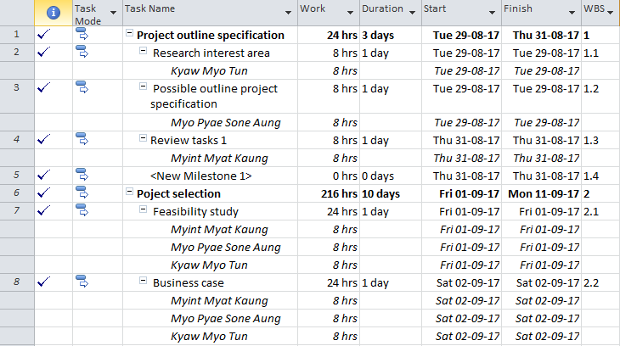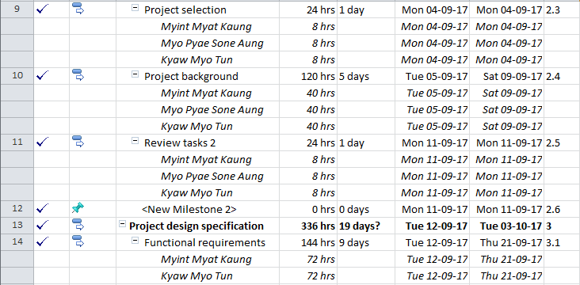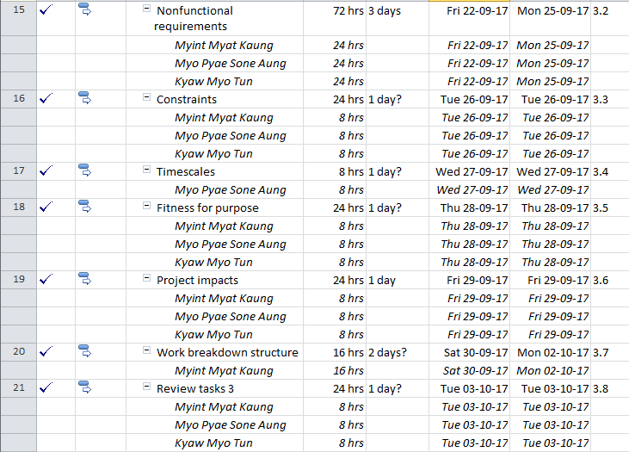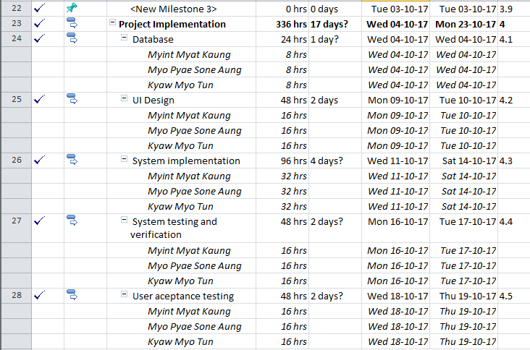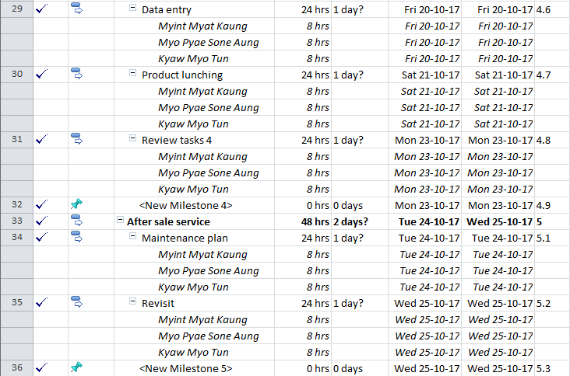

**Figure: 6.1 - Task description**

# 6.2 Project schedule

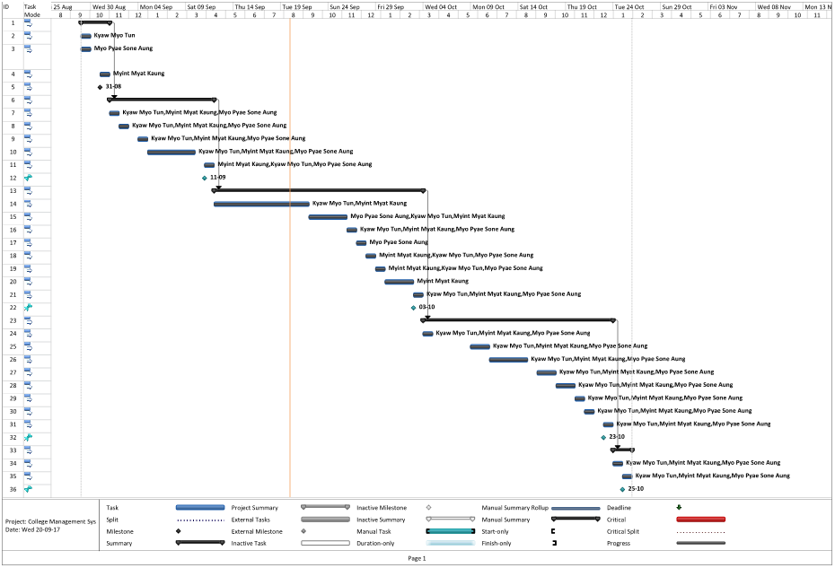

**Figure: 6.2 - Project schedule**

# 6.3 Monitoring Progress

## Set baseline

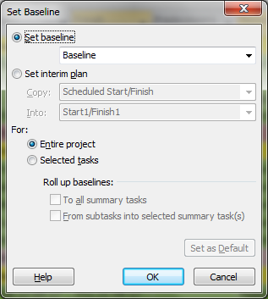

**Figure: 6.3 – Set Baseline**

# 6.4 Task Progress

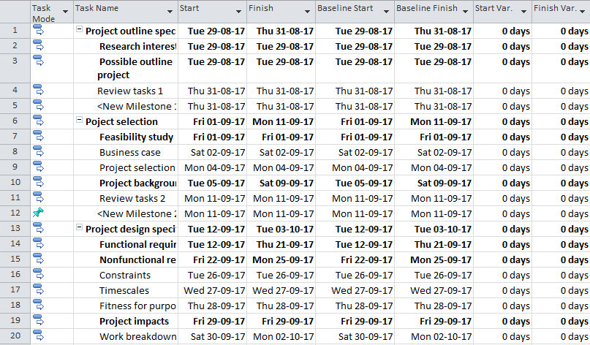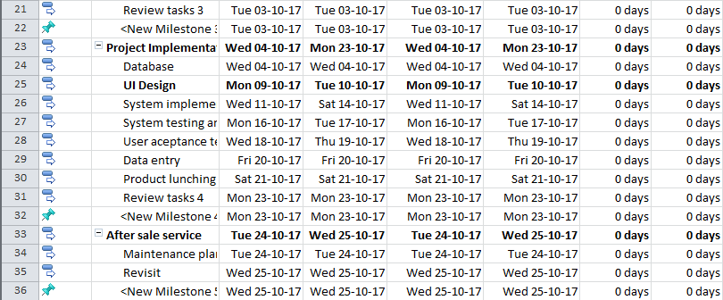

**Figure: 6.3 - Task Progress**

# 6.5 Resource Monitoring

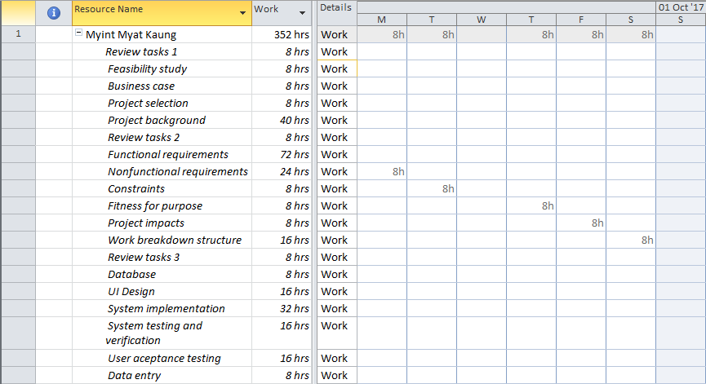

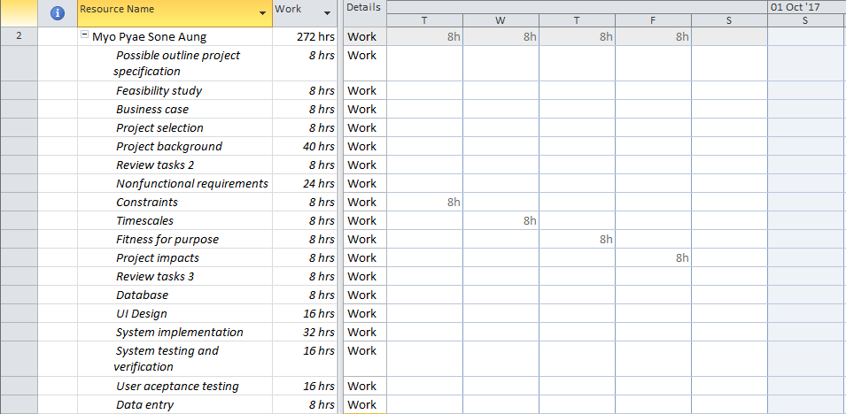

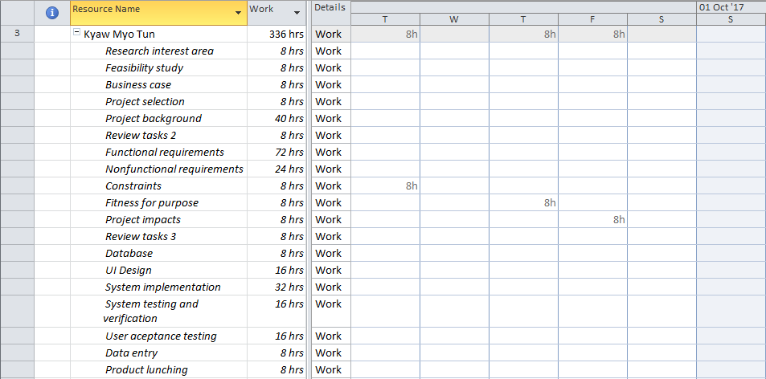

**Figure: 6.5 - Resource Monitoring**

References:

*Betterevaluation* [Online] Available from: <http://www.betterevaluation.org/en/evaluation-options/CostBenefitAnalysis>. [Accessed: 3rd September 2017]

*Apm* [Online] Available from: <https://www.apm.org.uk/body-of-knowledge/delivery/financial-cost-management/investment-appraisal/>. [Accessed: 3rd September 2017]

*Advanta* [Online] Available from: <https://advanta.io/software/benefits-school-college-management-system/>. [Accessed: 4th September 2017]

*Villanovau* [Online] Available from: <https://www.villanovau.com/resources/project-management/project-team-roles-and-responsibilities/#.WbjhAsZlDIU>. [Accessed: 5th September 2017]

*Ecomputernotes* [Online] Available from: <http://ecomputernotes.com/mis/information-system-planning/systemanalyst>. [Accessed: 5th September 2017]

*Monster* [Online] Available from: <https://hiring.monster.com/hr/hr-best-practices/recruiting-hiring-advice/job-descriptions/systems-analyst-job-description.aspx>. [Accessed: 5th September 2017]

*Designingbuildings* [Online] Available from: <https://www.designingbuildings.co.uk/wiki/Constraints_on_construction_projects>. [Accessed: 10th September 2017]

*Tutorialspoint* [Online] Available from: <https://www.tutorialspoint.com/management_concepts/project_contract_types.htm>. [Accessed: 10th September 2017]

*Brighthubpm* [Online] Available from: <http://www.brighthubpm.com/project-planning/53025-ethical-issues-in-project-management/>. [Accessed: 11st September 2017]

*Workbreakdownstructure* [Online] Available from: <http://www.workbreakdownstructure.com/>. [Accessed: 14th September 2017]

*Project-management-knowledge* [Online] Available from: <https://project-management-knowledge.com/definitions/e/effort/>. [Accessed: 16th September 2017]